Abstract template for NAno-ibct 2011
A. One⁽¹⁾, B. Two⁽²⁾, C. Three⁽¹⁾
⁽¹⁾ CIMAP, GANIL, boulevard Henri Becquerel, BP 5133, F-14070 Caen cedex 5, France
⁽²⁾ CIMAP, 6 boulevard du Maréchal Juin, F-14050 Caen cedex 4, France
This is a sample abstract for Nano-IBCT 2011. Abstracts must be received by Sunday 1st July 2011. They must be electronically submitted by email to nano-ibct@ganil.fr. Only abstracts with at least one Nano-IBCT 2011 participant will be included in the Book of Abstracts. The abstracts will be post-processed for publication in the Book of Abstracts; therefore, authors must follow the preparation instructions given below.
Abstracts should be written in English. Templates for Microsoft Office Word 97-2003, Microsoft Office Word 2007-2010, OpenOffice, and LaTeX are available on the Nano-IBCT webpage.
Abstracts must contain a title, the authors’ list and their affiliations. Among the authors, the corresponding author, attending Nano-IBCT 2011, should be underlined. The total abstract length should not exceed one A4 page, including figures and tables; the text length might be less than 2000 characters (spaces included). We encourage authors to include a figure (graphical abstract). The following figure formats are acceptable: jpeg, png, gif, eps, pdf. References in the text must be given by numbers in square brackets [1]. The list of references is placed at the end of the abstract text.
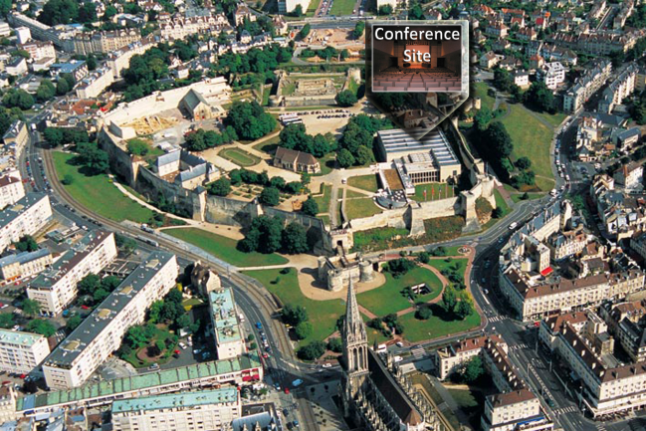
Figure 1: Conference site in Castle of Caen.
 | Title | Authors names | Affiliations | e-mail | Body text | Captions | Ref.
Size | 14 pt | 12 pt | 10 pt | 10 pt | 12 pt | 10 pt | 10 pt
Table 1: Font sizes for Nano-IBCT 2011 abstracts.
References
[1] J. D. Watson and F.H.C Crick, Nature, 171 964 (1953).

nano-ibct@ganil.fr

